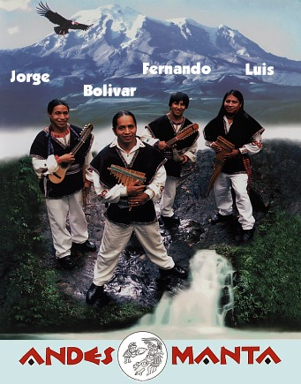
"Normally...we have a come and go audience, but your audience was so interested in your music that no one left; they just wanted more...."
Longwood Gardens, PA
"...a performance of incredible power and energy -- the crowd would not let them stop -- these guys are magic!"
State University of New York at New Paltz
The vibrant, powerful music of the Andes is played from Colombia to Tierra del Fuego, and none play it better than the four Lopez brothers who make up ANDES MANTA. Natives of the Ecuadorian Andes, the brothers learned their traditional folk music as it has been learned for thousands of years, passed from father to son, brother to brother.
Fernando, Luis, Bolivar and Jorge bring this unique art form to North America in its purest, most authentic form. Playing more than 35 traditional instruments, ANDES MANTA provides a rare opportunity for cultural understanding between the peoples of their homeland and North America.
In the Andes region of South America, songs and festivals mark life events such as the blessing of a new house, the birth of a child or the cycles of planting and harvesting. Energetic music and dance animate Andean religious festivals, blending pre-Colombian and Catholic rituals. Whether they sing in Spanish or Quechua, the first language of many Andean peoples, ANDES MANTA's moving performances have played to standing ovations on stage, screen and other venues.
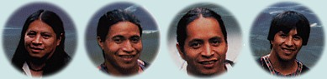
ANDES MANTA Programs
Concert of Andean Music
For Pre K through University audiences. Two 40-minute sets or One hour and fifteen minute show.
Panpipe Workshop
A start to finish lesson in creating individual instruments. Each participant receives a kit (materials fee required); the musicians teach the group panpipe assembly and how to play a simple traditional Andean song. 60 minutes. For all ages.
Lecture/Demonstration
Small group interaction between students and musicians. The ANDES MANTA musicians explain and demonstrate each instrument, discuss life in their home country of Ecuador and provide Spanish conversation practice with native speakers. 45 minutes to one hour.

